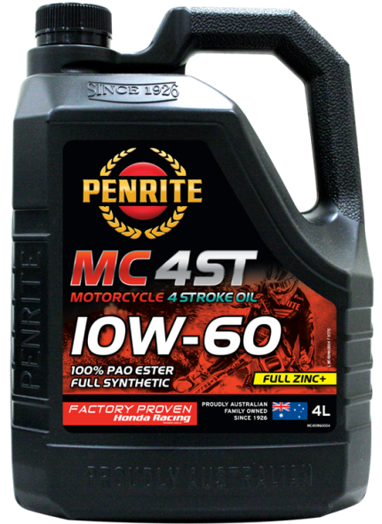
MC4-ST 10W-60
100% PAO & Ester Full Synthetic Engine Oil
Issue: July 2015
PRODUCT CODE | PACK SIZE | CTN / QTY
MC410W60004 | 4 Litre | 4
Product Description
MC-4 10W-60 is a premium 100% PAO & Ester full synthetic, SAE 10W-60, non friction modified, modern 4 stroke engine oil. It contains a superior anti wear package of *FULL ZINC + (exceeding 1800+ ppm levels) for ultimate engine, gearbox & clutch protection combined with the latest engine oil technology that provides protection against wear, corrosion, oil oxidation, piston deposits and sludge under all conditions.
MC-4 10W-60 exceeds the requirements of API SN/CF and JASO MA.
Application
MC-4 10W-60 is designed for use in modern four stroke road & sports bikes, dirt & enduro bikes, ATV’s/Quad bikes and 4 stroke scooters that require a full synthetic engine oil. It is also equally suitable for use in transmissions with wet clutch systems where engine & gearbox oils are combined. It has optimum clutch slip prevention in these systems and exceeds JASO MA requirements.
MC-4 10W-60 features an extra high operating temperature viscosity for increased protection under load and high temperature operating conditions. It can be used where semi synthetic or other types of oils are specified by the manufacturer including where SAE 10W-50 grade oils are recommended such as in Aprilia, Benelli, Cagiva, Husqvarna, KTM, Moto Guzzi, MV Agusta & more.
MC-4 10W-60 is a 100% PAO and Ester base engine oil providing superior oil film strength, heat resistance and oil shear protection. It provides an un-paralleled layer of protection for engine compression & oil sealing rings, cylinder sleeve lubrication, bearing and valve train.
MC-4 10W-60 is also suitable for use in other four stroke engines such as stationary engines & generators or other vehicles that require this grade and specification of engine oil. It is suitable for use with most petrol, racing and other conventional fuels.
Product Benefits
- Blended using 100% PAO (Poly Alpha Olefin – Group IV) and ESTER (Group V) base oils for maximum heat resistance and high performance
- *FULL ZINC + anti-wear additive package for ultimate engine wear protection
- LATEST oil specification technology exceeding petrol API SN for maximum wear protection, minimum sludge formation & reduced piston deposits
- MAXIMUM power and acceleration
- FACTORY PROVEN by competition race teams and trusted protection for performance engines
- Suitable for wet clutch systems (JASO MA)
- Extends engine life by reducing formation of high temperature engine deposits.
Industry Specifications
API SN/CF JASO MA
Typical Data
Viscosity, Kinematic, cSt
at 40°C 178
at 100°C 25.6
Viscosity Index 179
Viscosity, Cold Cranking, cP @ -25°C 5282
Ca content, mass % 0.296
B content, mass % 0.063
Zn content, mass % 0.124
Base Number 9.8

*Full Zinc + = Zinc level + Boron level combined as a total anti-wear package

Information in this sheet is based on recent production. Minor variations to typical properties are expected in normal manufacture and do not affect product performance. An MSDS is available on request.

